Assignment #1 – Business 100
Name:
Step 1: Product Life Cycle
Background Information Needed to Answer Question #1:

Review the Sales Report below for Alikay Naturals Moisturizing Black Soap Shampoo.


As you recall from our learning, here are the four phases of the product life cycle:
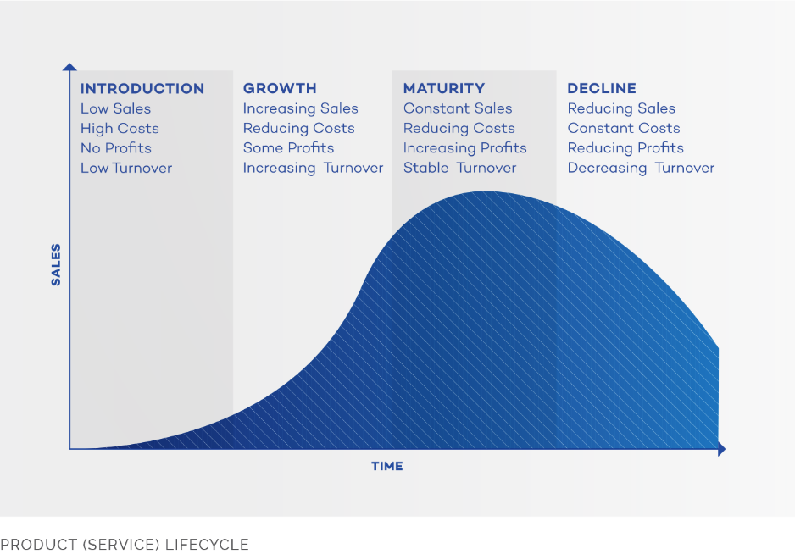

Question 1:
What phase of the product life cycle is the Moisturizing Black Soap Shampoo currently in?
- Introduction
- Maturity
- Growth
- Decline
Describe why you selected that phase using sales report data and what you know about the product life cycle in the box below:

Step 2: Product Changes
Background Information Needed to Answer Question #2:

Review the User Survey Summary data below and form some opinions about the shampoo’s consistency, smell, effectiveness, and price. Based on this information you will be able to answer question #2.
Question 2:
What recommendation(s) do you have for Alikay Naturals to improve or replace Moisturizing Black Soap Shampoo? Please support your recommendation(s) utilizing the data below:

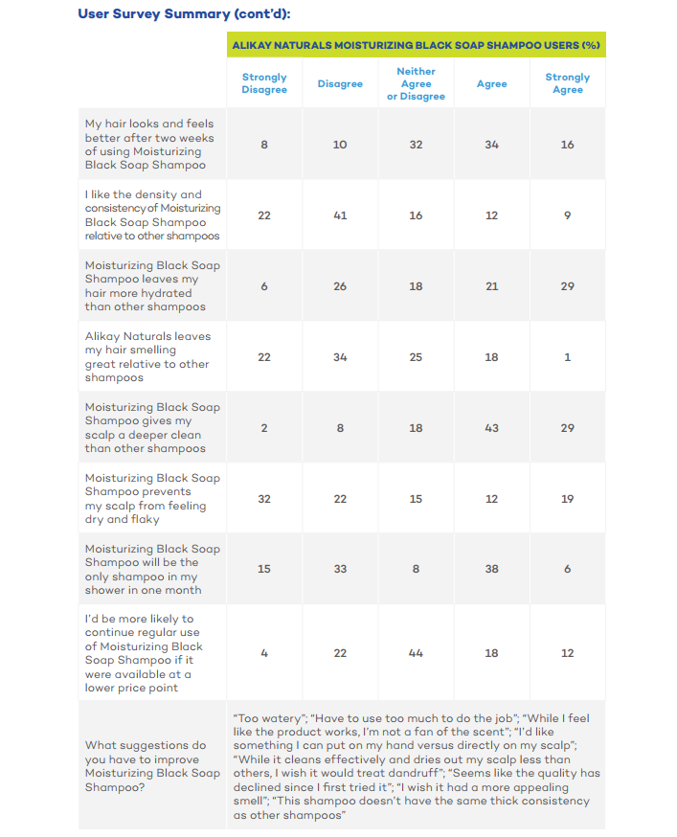
Step 3: New Product Development
Background Information Needed to Answer Question #3:
Review the three new product options and based on the survey results below determine which of the three new products you would recommend.

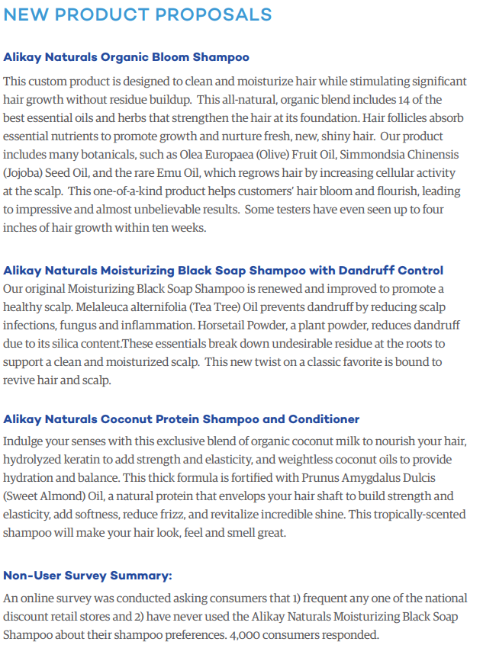
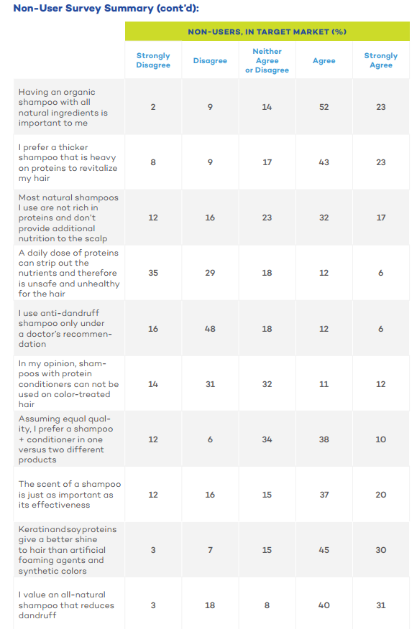
Question 3:
If you had to recommend one product, which product would you recommend they create? Underline or highlight your answer:
- Organic Bloom Shampoo
- Moisturizing Black Soap Shampoo with Dandruff Control
- Coconut Protein Shampoo and Conditioner

Explain your decision. Provide examples of the customer feedback that informed your choice.

question 4: Innovation
- Determine which type of innovation your new product represents from among the four main types discussed this week. Underline or highlight your selection:
- Sustainable (eco-friendly)
- Frugal
- Sustaining
- Disruptive

Briefly explain why you chose that type of innovation.

Helpful image from Week 2 Learn’s section for your review:

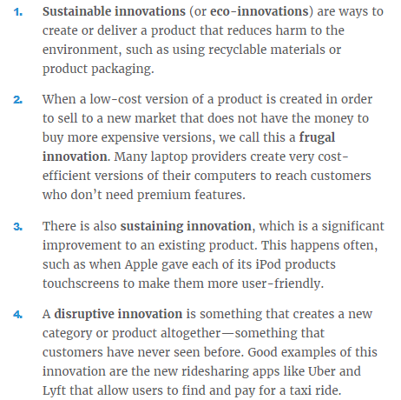

Question 5: Production Methods
Based on the product you chose in Answer 3 determine which production method is most appropriate for the production of this product. Underline or highlight your answer:
- Job Production
- Batch Production
- Flow Production
- Mass production

Explain your decision below:

Helpful images from Week 3 Learn’s section for your review:
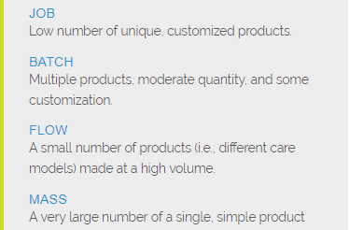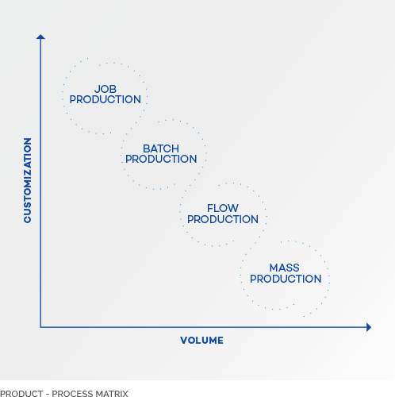

Next step: submit your work
- Save this document to your desktop
  - Navigation: select file at the top, save as – select desktop, and select save
- Log into your class and select Assignment #1 on the left, scroll down and select “submit your work”, click browser my computer, find your file on the desktop, click open, then click submit.
- If you have any issues please email me or call

I will provide you assignment feedback and you can then make any changes you would like and resubmit for grading.
Congrats on completing assignment #1!

